2020 Quick Sepsis Updates- CMS SEP-1

      - Please document reason if not sepsis for elevated lactate:
        - 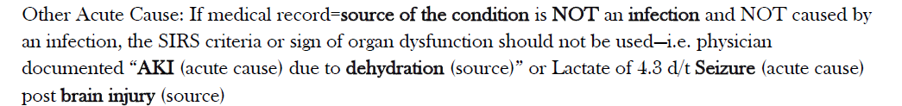
      - Updated Sepsis tool included

      - Review of changes to sepsis orders and physician documentation:

        - We are asking for Sepsis Order Sets be used when sepsis is identified to improved compliance with CMS measures.

        - This interventions and documentation needs completed within 6 hour window from sepsis identification to meet CMS requirements.

        - IF Sepsis ruled out, PLEASE update PROBLEM LIST and PLAN of CARE.

          - Mark ruled out on problem list, or REMOVE entirely from list

Updated Nursing Tool for Sepsis Interventions:
Sepsis Requirements | 3 Hour Bundle | 6 Hour Bundle
Initial Lactate Collection | Yes | Already Completed
Blood Culture Collection x 2 | Yes | Already Completed
Initial IV Antibiotic Started  - Must collect Blood Cultures before starting | Yes | Already Completed
30 mL/kg Fluid Bolus  - if SBP below 90 or Lactate 4 or greater  - 0.9 NS or LR (may use IBW if BMI over 30) | Yes if Indicated | Completed if Indicated
Repeat Lactate Collection  - if initial Lactate over 2  * Note – Lactate of 2.1 MUST be repeated even though  Lab results indicate this is a “normal” value | N/A | Yes  complete within 4 hours  after initial Lactate  *based on collection time
Vasopressor Given  - if hypotension continues after fluid bolus | N/A | Yes
Repeat Volume Status Assessment  - specific criteria required for this assessment  - MUST use paper Sepsis Documentation form or the  Sepsis Status section of electronic documentation | N/A | Yes  Complete within  2 hours after bolus finished

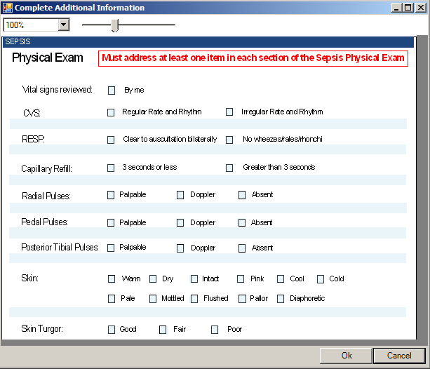
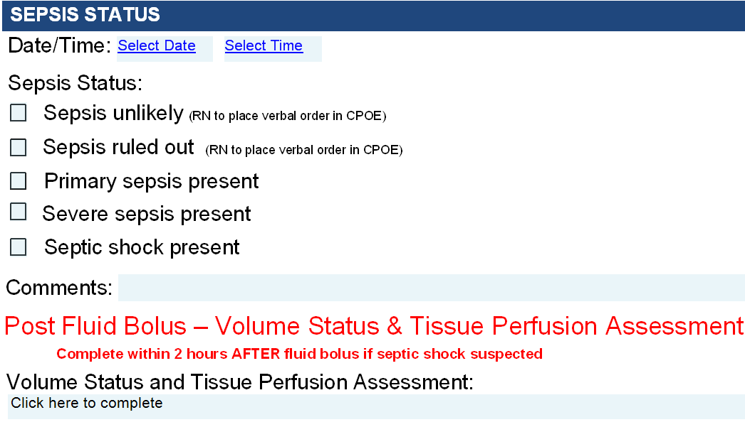
Sepsis Status section to replace all current Sepsis - Volume Status and Tissue Perfusion Status Assessment sections in the following PhysDoc templates:
- Emergency Department Documentation
- General History and Physical Note
- General Progress Note – Hospitalist
- General Progress Note
- OB Admit History and Physical Note
- OB Labor Progress Note B
- OB Postpartum Progress Note
- Orthopedics Progress Note
- Swing History and Physical Note
- Swing Progress Note B
- Telehospitalist Admit Note

- Phys Doc or Paper form available for documentation
- This documentation must be completed within the 6 hour window
from sepsis identification.

